USE UBANTU LINUX OS is requirement and internet also

step 1 :- goto source code compiled folder and see there are source code files
step 2 :- there is a file main.c
step 3 :- using linux open terminal window here and type command
$ sudo gcc main.c -o main
step 3 :- then to run the code type again second command
$ sudo ./main

step 4 :- now you code is running
step 5 :- now you have a shell for command that are mentioned there
-r tracefile
-s
-e
-m
-i
step 6 : - you have a packet like that in log file

***********************TCP Packet*************************

TCP Header
|-Source Port : 443
|-Destination Port : 57568
|-Sequence Number : 2732202218
|-Acknowledge Number : 3971416504
|-Header Length : 8 DWORDS or 32 BYTES
|-Urgent Flag : 0
|-Acknowledgement Flag : 1
|-Push Flag : 1
|-Reset Flag : 0
|-Synchronise Flag : 0
|-Finish Flag : 0
|-Window : 118
|-Checksum : 62640
|-Urgent Pointer : 0

DATA Dump
IP Header
TCP Header
Data Payload

###########################################################

step 7 :- you can see the screen shots of every command in each folder name
output images all parts

-e

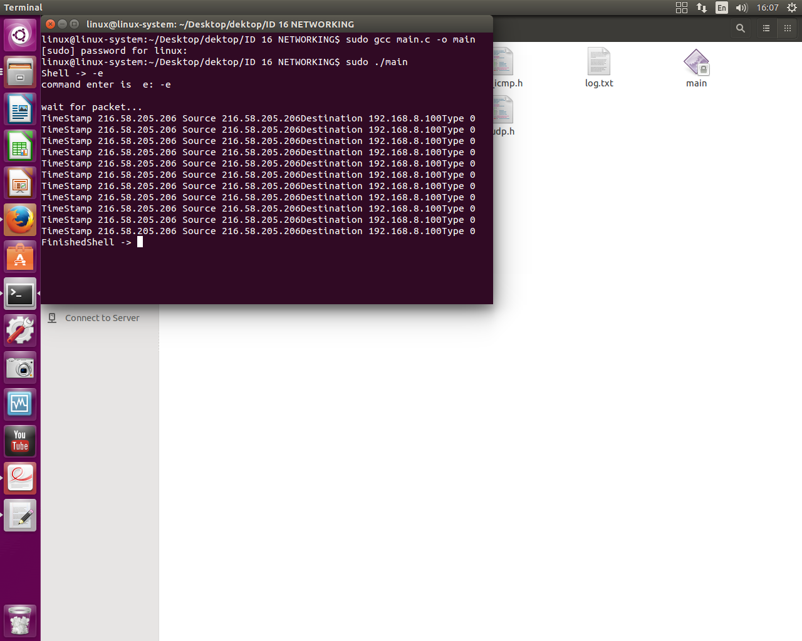

-s
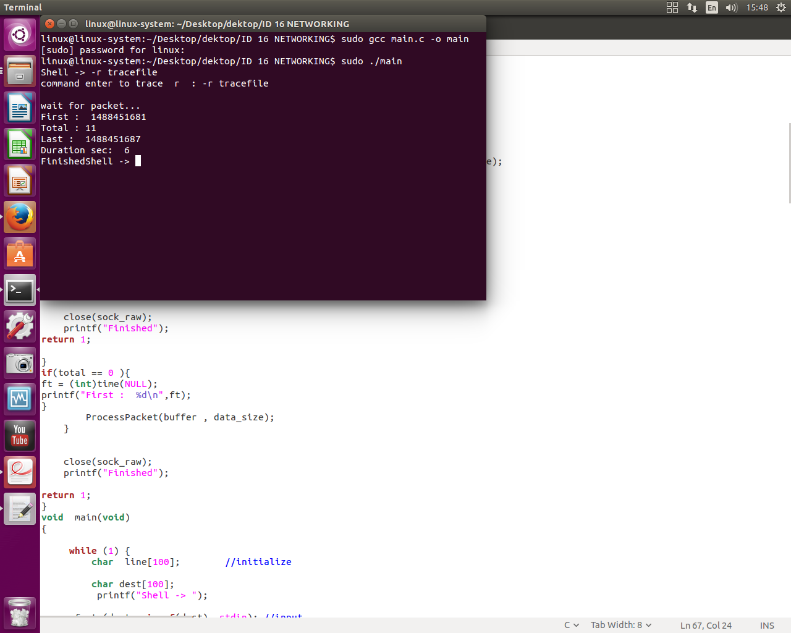

-i

-m
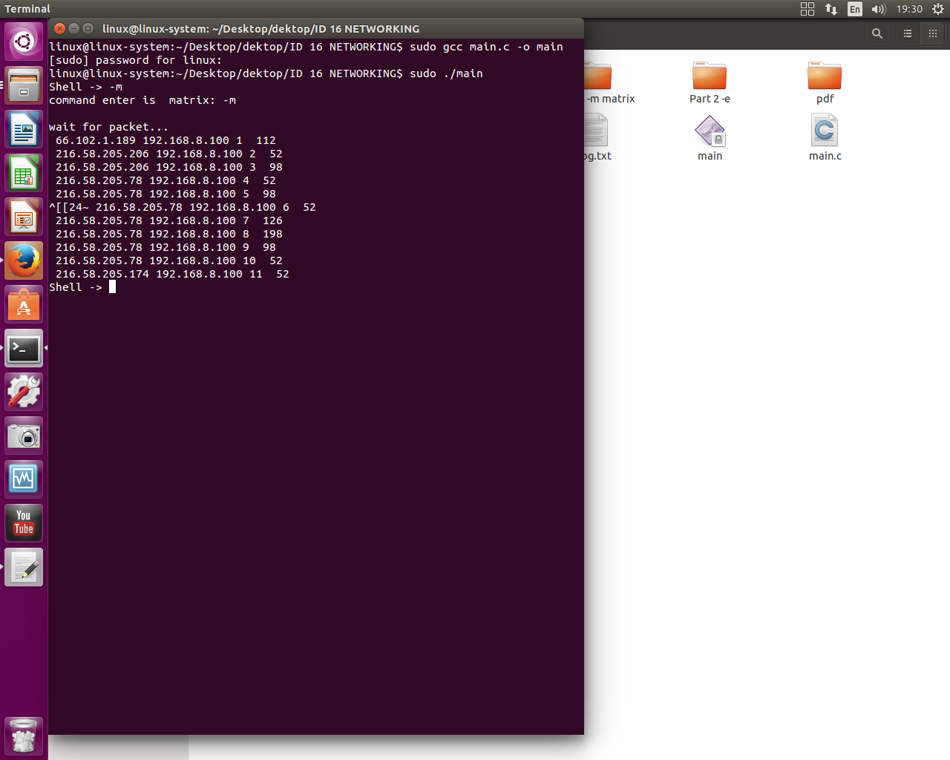

-t

